Haven Lodge, Gate 44, Apartment 18
Address: Haven Lodge, Gate 44, Apartment 18, Triq Francis Zammit, (ex L. Apap Street), St Julians

Local area: Haven Lodge is situated just a few minutes’ walk from the heart of Malta’s main entertainment capital which offers many bars, restaurants, cafes, nightclubs and shops. Also, in the vicinity is St. George’s sandy beach, Malta’s largest cinema complex, and a bowling alley. Local amenities include a large supermarket, bank, postal services and the St. Julian’s bus terminal.
Description of accommodation: Haven Lodge consists of 3-bedroom apartment in a quiet residential building with 2 bathrooms. Maximum of 6 students. The apartment has a fully- equipped kitchen including an oven, hob, microwave, toaster and fridge freezer. The living and dining area are equipped with cable TV. Recommended for 18 -29 (although 30+ can also book this accommodation option). Apartments are mixed gender.
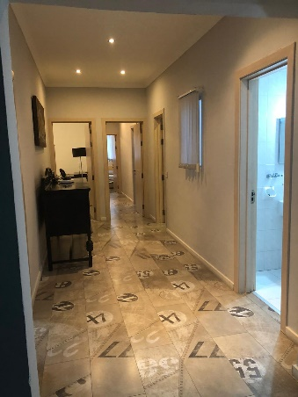

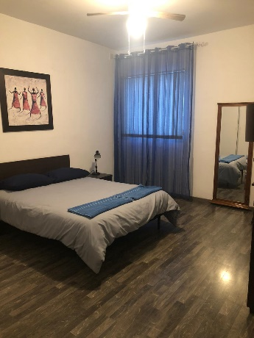
Minimum age – 18
Residence Type – Shared Apartment
Room type –Twin/Double
Bed type – Double/Single Bed
Bathroom – Shared Bathroom
Check in Time - 14:00hrs or later
Check out Time - 10:00am
Check in/check out Days - Saturday/Sunday
Internet - Free Wi-Fi
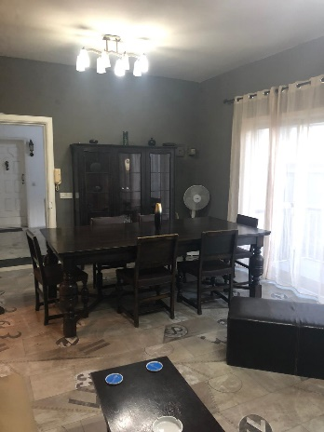
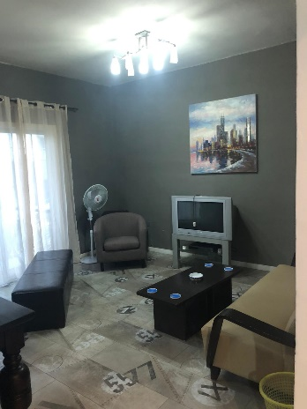
Cleaning - Apartments are cleaned on. In between cleaning, tenants are expected to keep their apartments in an orderly manner, including washing their own dishes and removing garbage
Linen - Bed linen, 1 Bath Towel.
Laundry - Washing Machine facilities are provided in the residence
Facilities - Maximum of 3 students sharing one bathroom. Fully equipped kitchen, including microwave. Living and dining area with balcony. Iron and ironing board available in each apartment. All apartments are accessed by lift
Room furnishing - Modern decoration
Board Basis - Self-catering
Smoking - Smoking is strictly not allowed in the apartment

